Interface
cat("\014") #Clears console
rm(list = ls()) #Clears Workspace&Environment
Installing Packages

GetData
getwd() #Returns the current path
setwd("C/pth") #Sets the path to the pointed path. Slash(/) is opposite side of Microsoft,
list.files() #Lists items in the active directory folder
newDataFrame <- read.table("clipboard",header=TRUE) #Easily creating dataframe from clipboard
var1 <- read.csv("path/XX.csv", header = TRUE) #Reads csv
class(cars.df) #Returns data type of an object
Preview of the Data
head(pokemon, n=6) #Shows first 6 rows of data (as default) to get an idea.
str(pokemon) #Data type and some data of columns
summary(pokemon) #Statistical Summary of Fields

Basics
data$newCol <- paste(data$col1, data$col2) # Combining col1 and col2 into a new column
pokemon[which.max(pokemon$HP),"Pokemon"] #Basically, Excel’s VLOOKUP
pokemon[which(pokemon$Pokemon=="Pikachu"),"No."] #RowNumber & Index Bulma
levels(x$a) #Shows Unique values in that column & factor
names(house_data) #to get col names
colnames(maas) <- c("exp","maas") #to change column names of a dataframe
colnames(maas)[2] <- "maas2" #to change only one column name
tableName <- subset(tableName, select = -colName) #To remove a column from a table (to remove an item from list, just call as tablename[1] and set it to null as: tablename[1] = NULL)
tableName$colName <- columnX >6 #To add a boolen(T/F) column to a table
length(unique(house_data$Suburb)) #Count and distinct count
tapply(table$numericCol, table$categorialCol, mean, na.rm = TRUE) #Finding average by a categorial column
table[order(table$col), ] #sorting
rbind(df1,df2) OR cbind(df1,df2) #Combines things as RowbyRow or ColbyCol
as.data.frame(table(mydata$colummn)) #To easily create Distinct values and their counts table
table <- table [, c("colname ", setdiff(names(table), " colname "))] #Moving a column to the front
Some visualization
Histogram
hist(maas$Salary) #draws histogram
hist(maas$Salary,breaks=3) #+sets num. of bins
hist(maas$Salary,breaks=3,xlab="Salaries") #+Sets X Axis Title
hist(maas$Salary,breaks=3,ylab="# of Occurance") #+Sets Y Axis Title
hist(maas$Salary,breaks=3,main="T1") # Sets Main;H1 Title
Scatter Plot Using ggplot
ggplot(maas, aes(x=YearsExperience,y=Salary)) +
geom_point(color='#000000', size = 2)+
labs(title= "Salary Over Years of Experience",x="Years",y="Salary") +
theme(
plot.title = element_text(hjust = 0.5,color="#ff0000"),# Center the title
axis.title.x = element_text(face = "bold"), # Bold x-axis label
axis.title.y = element_text(face = "bold") # Bold y-axis label
) +
geom_smooth(method=lm, se=FALSE, fullrange=TRUE, color='#ff0') #Lin. Reg. Trendline
Regression
model <- lm(Salary ~., data = salary_data) #syntax
summary(model) #Returns statistical summaries of the model such as R2, etc.
confint(model) # Returns confidence intervals
To use Regression Model for prediction;
new.dat <- data.frame(colName=11)
predict(model, newdata = new.dat, interval = 'confidence', level = 0.95)
Model Evaluation
set.seed(50)
sampleData <- createDataPartition(maas$maas,p=0.6,list=FALSE)
trainData <- maas[sampleData,]
testData <- maas[-sampleData,]
New Regression Model using training sample
tr.model <- lm(maas ~., data=trainData)
summary(tr.model)
tr.predictions <- tr.model %>% predict(trainData)
Train dataset Results
RMSE(tr.predictions,trainData$maas)
R2(tr.predictions,trainData$maas)
Test dataset Results
test.predictions <- tr.model %>% predict(testData)
RMSE(test.predictions,testData$maas)

#tobecontinued from Data Analytics materials
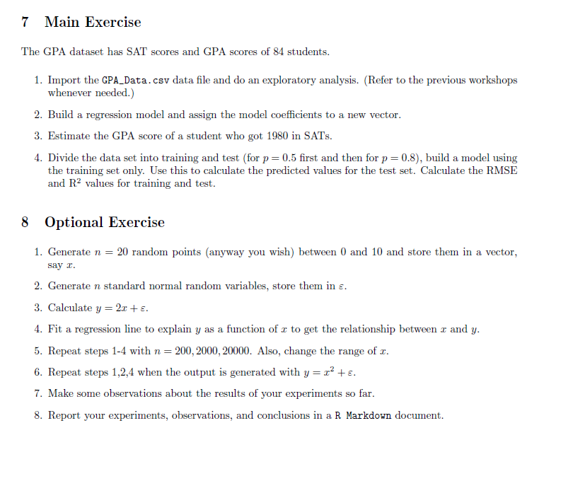

Statistics Course Week 3 lab
#Install Packages
install.packages("rmarkdown")
install.packages("LaTeX")
library(ggplot2)
#GetData
cars.df <- read.table("clipboard",header = FALSE)
class(cars.df)

#Changing ColumnNames
colnames(cars.df) <- c(
"mpg",
"cylinders",
"displacement",
"horsepower",
"weight",
"acceleration",
"year",
"origin",
"nam")

first200 <- cars.df()

# Create a new column for shapes based on the index
cars.df$shape <- ifelse(1:nrow(cars.df) <= 200, "p1",
ifelse(1:nrow(cars.df) <= 300, "p2", "p3"))

ggplot(cars.df, aes(x=horsepower,y=mpg,shape=shape)) +
geom_point(color='#f3306c', size = 2)+
#scale_shape_manual(values = cars.df$shape, shape=2) + # '1' is for open circle, '16' is for filled circle
labs(title= "Graph of MPG & Horsepower",x="HorsePower",y="MPG") +
scale_shape_manual(values = c("p1" = 16, "p2" = 17, "p3" = 3)) + # 16 = circle, 17 = triangle, 3 = plus
theme(
plot.title = element_text(hjust = 0.5,color="#ff0000"),# Center the title
axis.title.x = element_text(face = "bold"), # Bold x-axis label
axis.title.y = element_text(face = "bold"), # Bold y-axis label
)

